PLAN AND PROCEDURES FOR THE INADVERTENT DISCOVERY OF CULTURAL RESOURCES AND HUMAN SKELETAL REMAINS

SPIIL NAME:

LOCATION:

County:

DATE:

Unified Command | Name | Signature
FOSC
SOSC
RPIC
LOSC

TOSC

Inadvertent Discovery Plan for Cultural Resources

Click or tap here to enter text.

This Inadvertent Discovery Plan (IDP) should be followed if any cultural materials, including human remains, are encountered during operations. The IDP must be reviewed and discussed with all supervising personnel performing fieldwork in advance of commencing any such work. Direction for field staff may be contained in ICS 204 forms and should be followed. In addition, the IDP must be immediately available on-site at all times, be implemented to address any discovery, and be available by request by any party.
- INTRODUCTION:
Cultural resources are physical remains or indicators of past human activity. They include structures and objects that provide evidence of our human history. Cultural resources show us how people lived in the past. Protecting cultural resources preserves human traditions, culture, and history.

The Unified Command is required to comply with state and federal laws that protect cultural resources from injury. Cultural resources may be damaged from the oil or hazardous substance that has been released or due to actions of the response itself. The Environmental Unit helps the Unified Command ensure that cultural resources are appropriately considered during emergency response activities. Tribes may desire to have a tribal monitor on-scene to observe response operations. Response personnel including contractors, sub-contractors, emergency responders, cleanup workers, and field crews play a crucial role in this process since they, by the nature of their work, are the people most likely to encounter cultural resources while in the field.

The following Inadvertent Discovery Plan (IDP) outlines procedures to perform in the event of discovering cultural resources or human remains, in accordance with the Northwest Area Contingency Plan and federal and state laws. These laws concern historic preservation, archaeology, human remains, and cemeteries. Compliance with these procedures is mandatory.

If there is an inadvertent discovery of cultural resources, archaeological excavations may be required after the emergency response phase of the incident. This is handled on a case by case basis by the professional archaeologist and project manager, in consultation with SHPO and appropriate tribes.
- TRIBAL MONITORS
A tribal monitor will be on-scene to observe response operations and monitor compliance with the actions described in this Inadvertent Discovery Plan.

Tribe | Name | Contact Information
 |  | List phone and email
- AVOID DISTURBING CULTURAL RESOURCES:
The inadvertent discovery of cultural resources should be avoided if possible. There are several best practices that can be applied to emergency response operations to minimize disturbances to cultural resources.

☐ Minimize (ground, seafloor, riverbed, lakebed, etc.) disturbances.
☐ Keep all equipment on hardened surfaces. Utilize existing hardened access paths and paved areas when approaching shorelines.
☐ Consult the Cultural Resources Protection Plan for detail on protecting known and suspected cultural resources, if applicable.
☐ Understand what a cultural resources might look like. When in doubt, assume the material is a cultural resource. See Section 7 and Appendix A for a description of cultural resources.
- IF A CULTURAL RESOURCE IS ENCOUNTERED:

Discovery in the Field
During an incident response in the Pacific Northwest it is possible that you, as a person involved in the response, may discover cultural resources. In the course of your work if you find an item that you believe or suspect is cultural or historic, you must:

- Stop Work and Inform Field Supervisor. If you believe you uncovered a cultural resource at any point in the response, leave it in place and stop work in the area immediately. Inform your field supervisor of the discovery. Leave the suspected cultural item in place, undisturbed, exactly where it was discovered. Do not pick the item up, touch it, or work around it. If possible, mark the location where you discovered the item but do not disturb or penetrate the soil with any object or tool. There may be other artifacts under the soil that could be damaged by your actions.

- Initial Notifications and Direction. The Field Supervisor will make initial notifications and provide an initial briefing to the Environmental Unit Lead and the Historic/Cultural Resource Technical Specialist. They will also inform their direct supervisor of the discovery and consult with the on-scene tribal monitor. The Field Supervisor should direct field personnel to begin securing the discovery while notifications are being made. The Field Supervisor should be prepared to report:
- General location of the discovery
- Description of the discovered artifact
- Description of how the discovery was made
- Impacts to response efforts

Field Notifications
Position | Name | Contact Information
Environmental Unit Lead |  | List phone and email
Historic/Cultural Resource Technical Specialist

Notifications for the Discovery of Human Remains
If possible human remains are encountered, the Field Supervisor will also notify the appropriate authorities based on the location of the find and follow directions provided in Section 5 regarding the discovery of human remains.
Agency Name | Contact Type | Contact Information
Local law enforcement | Emergency | 911
Local law enforcement | Non-Emergency
County medical examiner/coroner’s office

- Secure the discovery. The Field Supervisor will direct personnel to secure the discovery by placing a temporary fence or other onsite security around the discovery. Do not allow vehicles, equipment, or unauthorized personnel to traverse the discovery area. Delineate and secure the area to protect the integrity of the discovery (generally 20 yards in all directions at minimum). Do not disturb the discovery in any way. Do not take photographs of the discovery unless photographs are requested by the SHPO. Do not talk to the media about the discovery. Record the discovery in the unit log with the following statement: “In accordance with the Inadvertent Discovery Plan for Cultural Resources, work has stopped at this site.” Do not elaborate as to what specifically was discovered.

- Wait for further directions from Unified Command. After the initial notifications are made, Command and General Staff at the command post will be making subsequent notifications to tribal governments, the State Office of Historic Preservation, and other appropriate interested parties. Trained archeologists and anthropologists may need to visit the site to assess and document the discovery before work can resume. After consultations with these groups, Unified Command will make informed decisions about the discovery and emergency response efforts. Field workers should not resume work in the delineated discovery area until directed by Unified Command. The Field Supervisor may direct field personnel to resume work away from the discovery area.

Compliance with these procedures is mandatory. They must be followed by all response personnel. Failure to comply with these procedures by excavating, removing, damaging, altering, or defacing any archaeological resource is a violation of multiple state and federal laws and may result in fines/penalties, criminal prosecution, and imprisonment. For more information on actions related to the discovery of cultural resources, consult with your supervisor or contact the Historic/Cultural Resource Specialist.

Notifications from the Command Post
After a cultural resource or potential cultural resource is discovered and reported, command and general staff will work to notify and consult with tribal governments, state and federal agencies, and other interested parties following these notification protocols.

The Environmental Unit Lead will notify Unified Command and Command Staff and consult about additional notifications needed:
Position | Name | Contact Information
Unified Command |  | List phone and email
Planning Section Chief

The Historic/Cultural Resource Specialist (or Environmental Unit Leader) will notify offices of historic preservation.
Agency | Name and Title | Contact Information
Washington State Department of Archaeology and Historic Preservation | https://dahp.wa.gov/about-us/staff-directory | List phone and email.
Oregon or Idaho SHPO if applicable
List all relevant THPO and/or tribal representatives on cultural issues | https://dahp.wa.gov/sites/default/files/WashingtonTribescontactList_8.1.2019_1.pdf
List all relevant Federal trustee agencies, if any.
- SPECIAL PROCEDURES FOR THE DISCOVERY OF HUMAN REMAINS
Any human skeletal remains, and/or potential funerary objects, regardless of antiquity or ethnic origin, will at all times be treated with dignity and respect. Do not take photographs unless you are pre-approved to do so by the physical anthropologist or coroner’s office.

If human remains or potential human remains are discovered, the Field Supervisor must follow the procedures described in Section 4 regarding the inadvertent discovery of cultural resources and the following special procedures for the discovery of human remains.

- Notify appropriate authorities. The Field Supervisor will immediately call the local law enforcement agency and the medical examiner/coroner’s office (contact information listed in Section 4). In addition, the Environmental Unit Lead and the Historic/Cultural Resource Technical Specialist must be notified of the discovery so that they can initiate their notification procedures.

- Follow the Inadvertent Discovery Procedures describes in Section 4. Stop work, secure the discovery, make notifications to the Command Post, and wait for further direction.

- Assist law enforcement and the Medical Examiner/Coroner. Provide assistance as personnel arrives on-scene. The Medical Examiner/Coroner (with assistance of law enforcement personnel) will determine if the remains are human and whether the discovery site constitutes a crime scene. If the remains constitute a crime scene (forensic), the medical examiner will retain jurisdiction. If they do not constitute a crime scene (non-forensic), the medical examiner will notify Washington State Department of Archaeology and Historic Preservation (DAHP). The DAHP and the SHPO will consult with Unified Command.

- Wait for further direction from Unified Command. Work in the discovery area may resume only as directed by the medical examiner/law enforcement personnel for forensic remains, or by DAHP for non-forensic remains. Unified Command will relay these decisions to the field supervisor.
- RECOGNIZING CULTURAL RESOURCES
A cultural resource includes historic and prehistoric sites and objects. Examples include:
- An accumulation of shell, burned rocks, or other food related materials.
- Bones or small pieces of bone.
- An area of charcoal or very dark stained soil with artifacts.
- Stone tools or waste flakes (i.e. an arrowhead. or stone chips).
- Clusters of tin cans or bottles, logging, agricultural, or other equipment that appears to be older than 50 years.
- Buried railroad tracks, decking, or other industrial materials.
See images in Appendix A for additional examples. When in doubt, assume the material is a cultural resource.
APPENDIX A: REFERENCE IMAGES OF CULTURAL RESOURCES
We recommend that you print images in color for accuracy.

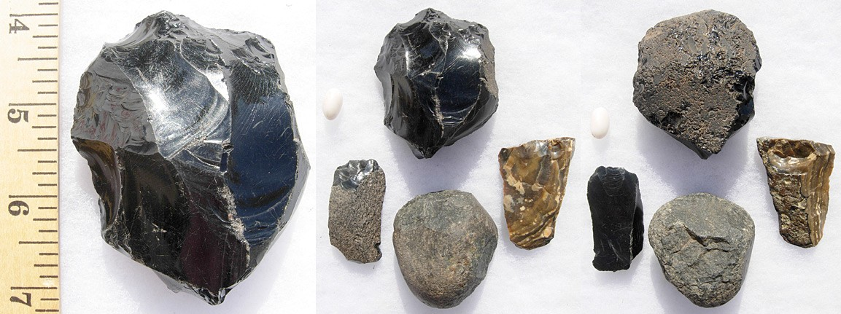
• Glass-like material

• Angular

• “Unusual” material for area

• “Unusual” shape

• Regularity of flaking

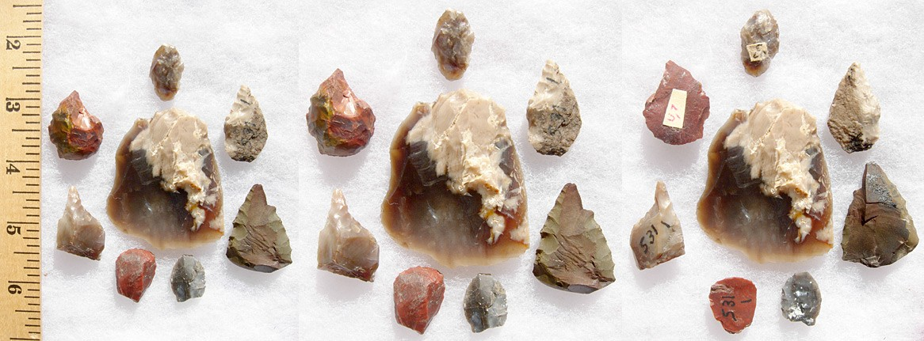
• Variability of size

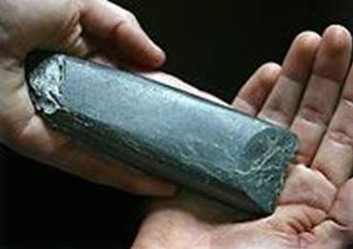
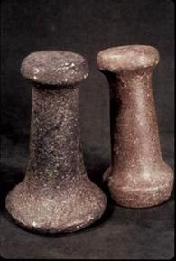
• Striations or scratching

• Unusual or unnatural shapes

• Unusual stone

• Etching

• Perforations

• Pecking

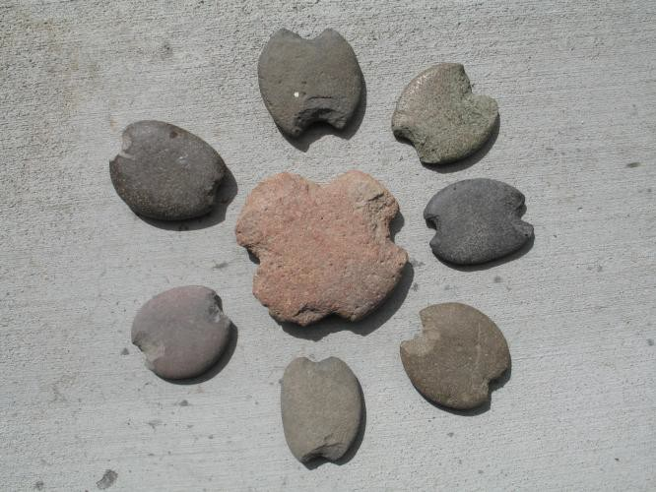
• Regularity in modifications

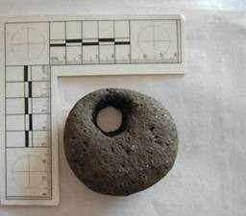
• Variability of size, function, and complexity

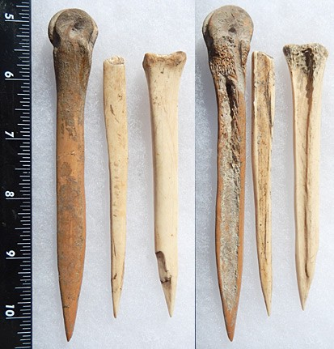
• Often smooth

• Unusual shape

• Carved

• Often pointed if used as a tool

• Often wedge shaped like a
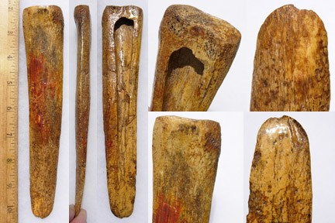
“shoehorn”

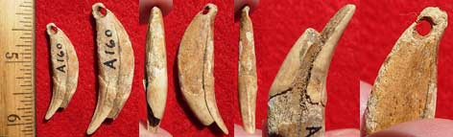
• Often smooth

• Unusual shape

• Perforated

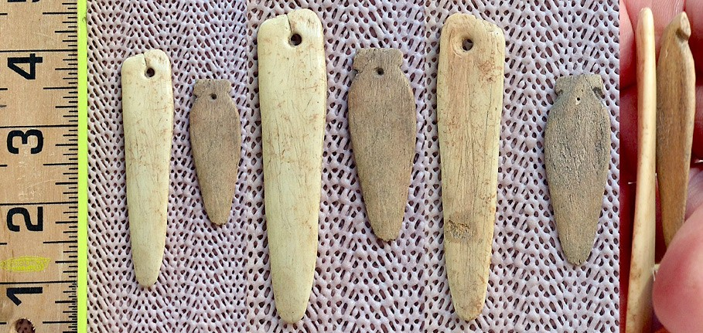
• Variability of size

You see fiber or wood artifacts.

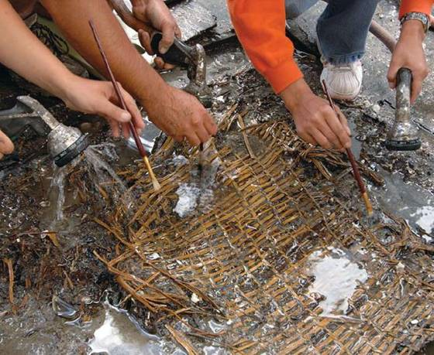
• Wet environments needed for preservation

• Variability of size, function, and complexity

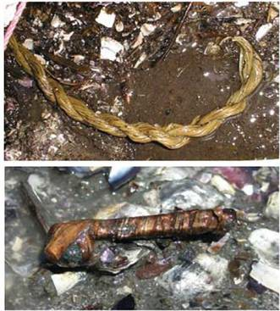
• Rare

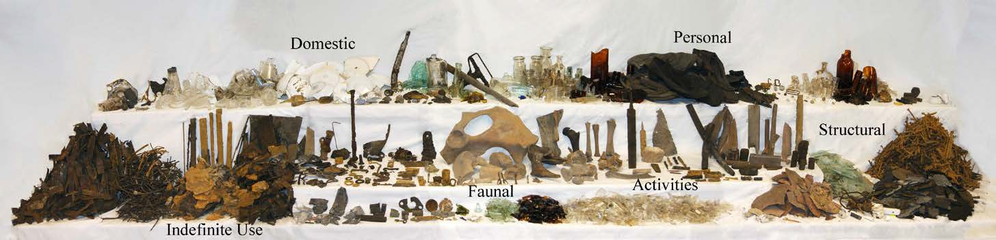

Paragraph head 16 pt. Paragraph head 16 pt. Paragraph head 16 pt.

Paragraph text 14 pt. Paragraph text 14 pt. Paragraph text 14 pt.
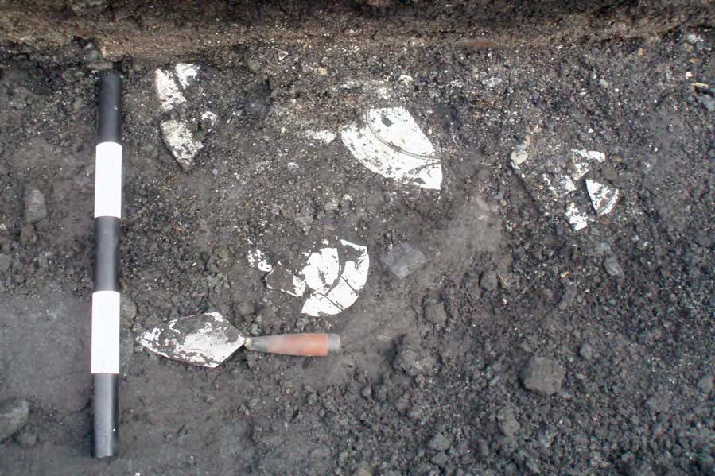
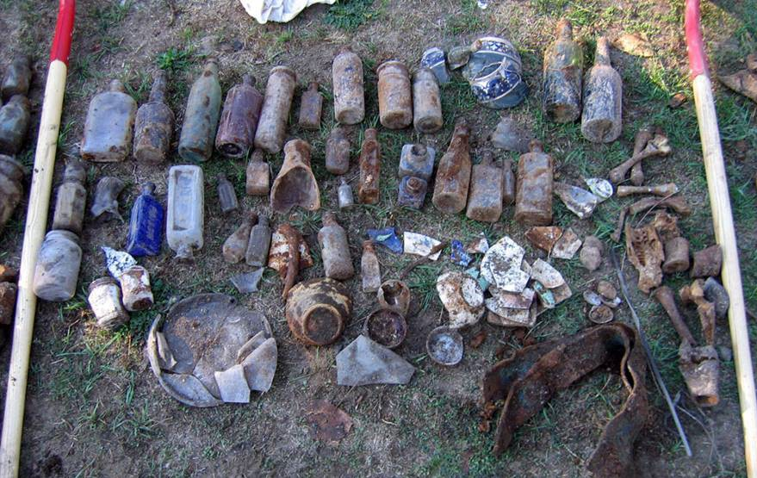
You see historic period artifacts.

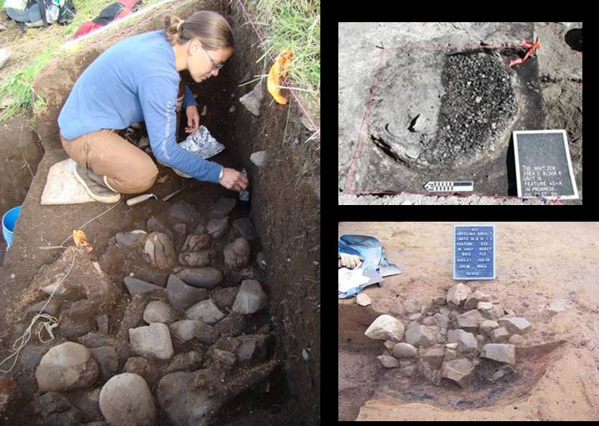
• Human activities leave traces in the ground that may or may not have artifacts associated with them

• “Unusual” accumulations of rock (especially fire-cracked rock)

• “Unusual” shaped accumulations of rock (e.g., similar to a fire ring)

• Charcoal or charcoal-stained soils

• Oxidized or burnt-looking soils

• Accumulations of shell

• Accumulations of bones or artifacts

• Look for the “unusual” or out of place (e.g., rock piles or accumulations in areas with few rock)

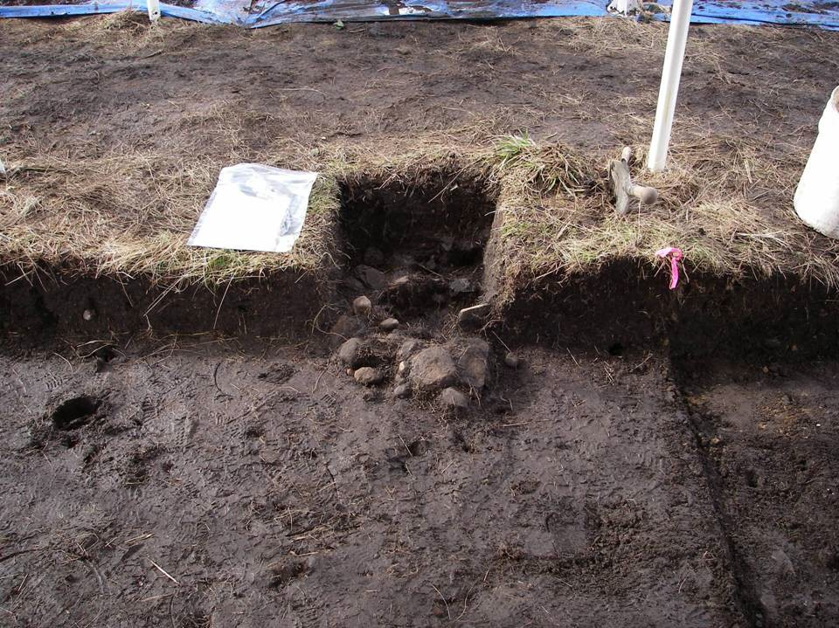
• “Unusual” accumulations of rock (especially fire-cracked rock)

• “Unusual” shaped accumulations of rock (e.g., similar to a fire ring)

• Look for the “unusual” or out of place (e.g., rock piles or accumulations in areas with few rock)

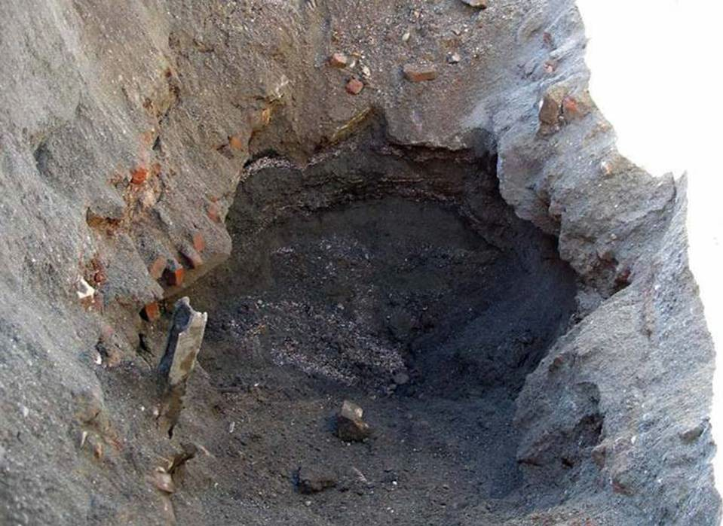
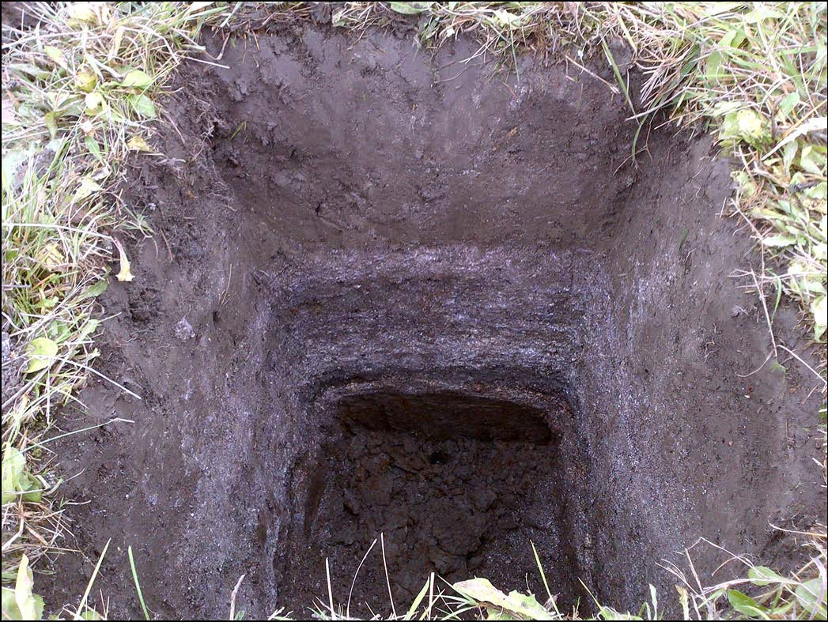

Layers of shell midden
• Often have a layered or
“layer cake” appearance

• Often associated with black or blackish soil

• Often have very crushed and compacted shells

Site located within WSDOT ROW near Anacortes Ferry Terminal 9

Historic Debris

Implement the IDP I UDP if ...

You see historic foundations or buried structures.
